2023 Car, Truck & Motorcycle Show
Registration
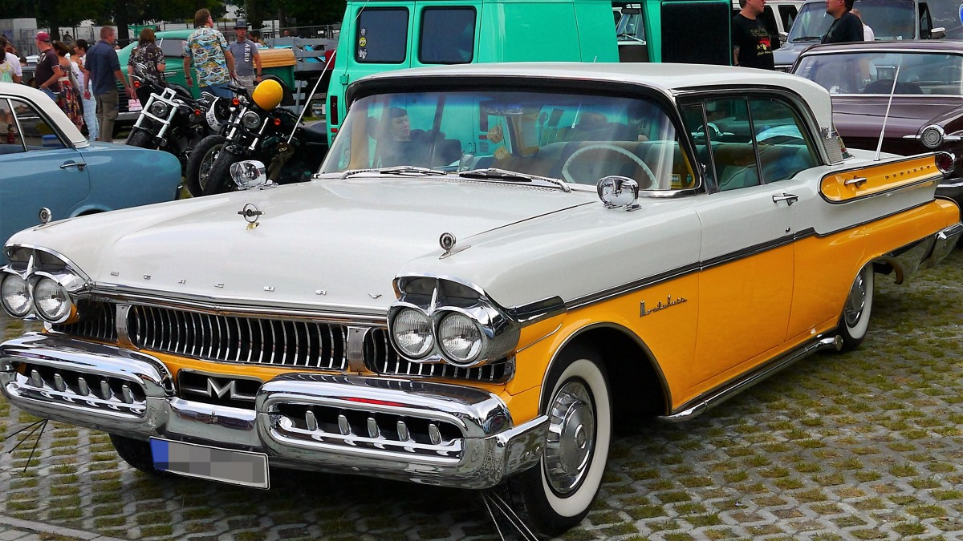

Name: _________________________________________

Address: ________________________________________

City: ______________ State: ____ Zip: ______________

Phone: _________________________________________

Email: __________________________________________

Year of Vehicle: __________ Make: __________________

Model ___________________________________________

Entry Fee: $25
Liability Waiver: I the undersigned participant here agree to indemnify, save & hold harmless, its subsidiaries, agents, volunteers, sponsors, or and persons or representative from any and all liability arising out of or in any way relating to my participation in the Freedom Fest Car Show.
We reserve the right to refuse admittance to any persons or vehicle which in our sole opinion is not in keeping with the quality or safety of the show.

Signature Required: ______________________________________ Date: _______________

