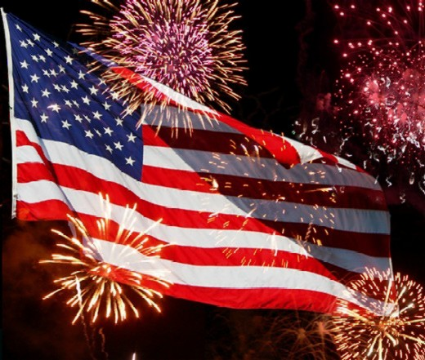

Rainsville Freedom Fest
June 29, 2024
Registration Form

- All registration forms must be received by June 21, 2024

- No Vendor will be assigned a vendor space until all registration forms are received.

- In order to provide a diversity of products and to protect vendor interest, exclusive and limited number of various types of vendors will be granted. Please provide a detailed description of your product, along with any special details of product marketing.
Only pre-approved products will be permitted, and all items must meet the standards of the Festival Committee in terms of appropriateness and good taste. The Committee reserves the right to remove any items not approved or deemed inappropriate. Exhibitors must abide by the rules and decisions of the committee.

- Each vendor will be responsible for their own drinks, ice, trailers/tents/tables/electrical cords, needed for their space.
The City of Rainsville will not supply any of these items.

- No water, drinks, food or other items to be given away in the park without permission from the Festival Committee.
No Arts/Crafts Vendors are allowed to sell food in their stations.
No selling or soliciting outside the booth area.

- Inappropriate toys such as projectile toys (sling shots, guns, catapults, real-like weapons) and fake tobacco products will not be allowed on the premises. No alcohol, drugs, firearms, weapons, or fireworks or pets are allowed on the premises.

Signed ______________________ Date: __________________
Art/Crafts : _______ Booth #: _________

Food Vendor: ______
Vendor Set-Up
Vendors may begin setting up from 4pm until 7pm on Friday, June 28, 2024
Vendors may also set up Saturday morning, June 29th, from 8am until Noon.
No set up will be permitted after 12:00 the day of the festival.
After set up, all vehicles & trailers must be moved to parking lot.

I, the undersigned, holds harmless the City of Rainsville or the Freedom Fest Committee from any and all damaged, injuries, losses and expense incurred by any persons or entity that may arise due to participation in the Rainsville Freedom Fest.

I, the undersigned, have read and agree to abide by the rules defined by the Festival Committee for Vendors to the Rainsville Freedom Fest.

Name: ___________________________________________________________

Address: _________________________________________________________

City: _____________________________________ Zip: _________________

Phone: ________________________ Email: __________________________

Product/Craft/Food:_____________________________________________________

Need Electricity: Yes: _______ No: _________ Using Generator__________

10x10 _____ 10x20 _____ 10x30 _____ 10x40 _____ 10x50_____

Fee: $40.00 for 10x10 spot. Checks Payable: City of Rainsville

Signed: ___________________________________ Date: ________________

For more information contact: Sandy Goff, Freedom Fest Committee
PO Box 396, Rainsville, AL 35986
Phone: 256-717-8886,
Email: sandygoff@farmerstel.com

